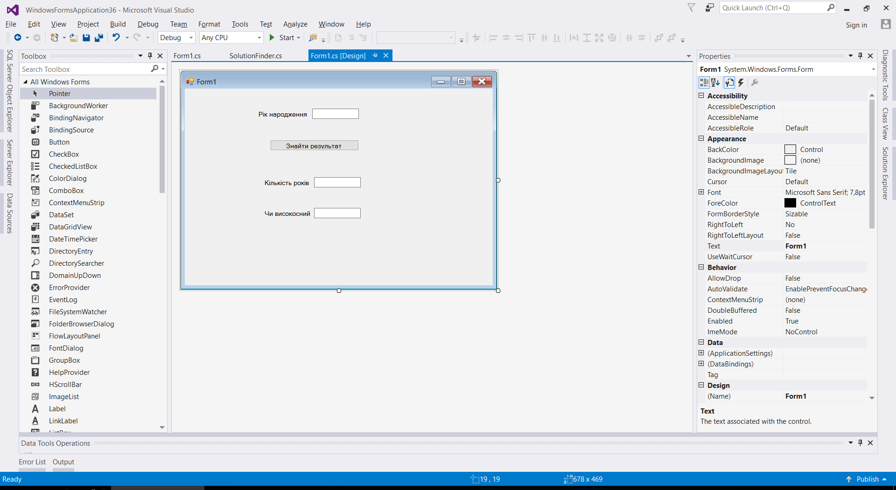

using System;

using System.Collections.Generic;

using System.Linq;

using System.Text;

using System.Threading.Tasks;

namespace WindowsFormsApplication36

{

class SolutionFinder

{

public static int getAge(int year)

{

return DateTime.Now.Year - year;

}

public static bool isLeapYear(int year)

{

return year % 4 == 0 && year % 100 != 0 || year % 400 == 0;

}

}

}

==========================

using System;

using System.Collections.Generic;

using System.ComponentModel;

using System.Data;

using System.Drawing;

using System.Linq;

using System.Text;

using System.Threading.Tasks;

using System.Windows.Forms;

namespace WindowsFormsApplication36

{

public partial class Form1 : Form

{

public Form1()

{

InitializeComponent();

}

private void button1_Click(object sender, EventArgs e)

{

textBox2.Text = SolutionFinder.getAge(int.Parse(textBox1.Text)).ToString();

if (SolutionFinder.isLeapYear(int.Parse(textBox1.Text)))

{

textBox3.Text = "Високосний";

}

else

{

textBox3.Text = "Не є високосним";

}

}

}

}